Say, “God, if you are really up there and if Yeshua (Jesus) is really the Way, the Truth and the Life, please show me.”

Want to talk about it?
Want to come to one of our gatherings?

Copyright druckerbrian@yahoo.com

Say, “God, if you are really up there and if Yeshua (Jesus) is really the Way, the Truth, and the Life, please show me.”

Want to talk about it?
Want to come to one of our gatherings?

Copyright druckerbrian@yahoo.com

Worldwide food shortages are predicted.
The dollar is quickly losing its buying power.
There is a real threat of war against the USA.
How did we get here, and what should we do?

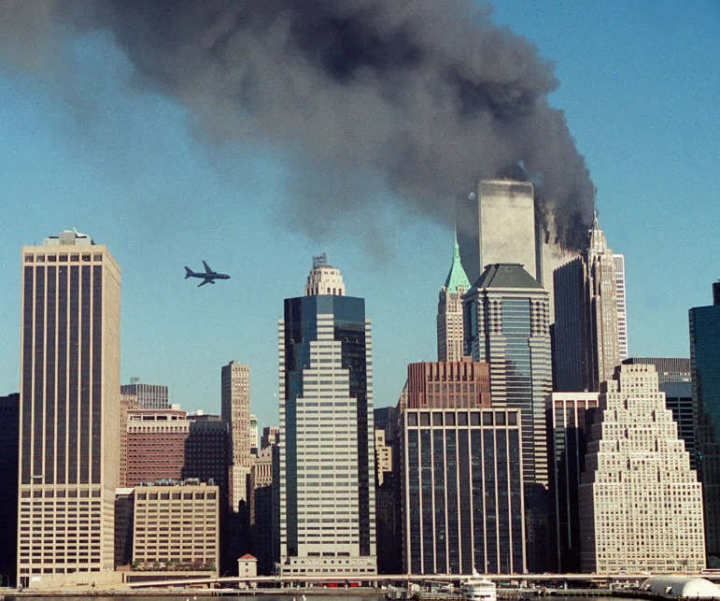
Worldwide food shortages are predicted.
The dollar is quickly losing its buying power.
There is a real threat of war against the USA.
How did we get here, and what should we do?

